Program 1:

//Program to check if number is divisble by 5 or not.

#include<stdio.h>
int main(){
printf("Enter a number: ");
int num;
scanf("%d",&num);
if(num%5==0)
printf("\n%d is divisible by 5\n",num);
else
printf("\n%d is not divisible by 5\n",num);
}

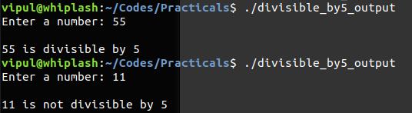

Program 2:

//Program to check if number is >0 || <0 || ==0.

#include<stdio.h>
int main(){
int num;
printf("Enter number: ");
scanf("%d",&num);
if(num>0)
printf("\n%d is >0\n",num);
else if(num<0)
printf("\n%d is <0\n",num);
else
printf("\n%d is =0\n",num);

}

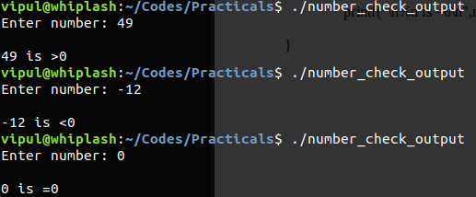

Program 3:

//Program to check if number is even or odd.

#include<stdio.h>
int main(){
int num;
printf("Enter number: ");
scanf("%d",&num);
if(num%2==0)
printf("\n%d is an even number\n",num);
else
printf("\n%d is an odd number\n",num);
}

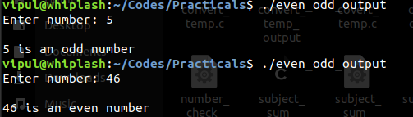

Program 4:

//Program to check if year entered is leap year or not.

#include<stdio.h>
int main(){
int year;
printf("Enter year: ");
scanf("%d",&year);
if(year%4==0)
printf("\n%d is a leap year.\n",year);
else
printf("\n%d is not a leap year.\n",year);
}

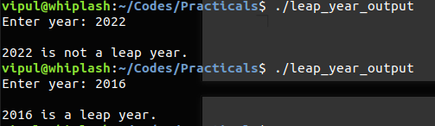

Program 5:

//Program to check greatest among three numbers.

#include<stdio.h>
int main(){
int num[3];
printf("Enter 3 numbers:\n");
scanf("%d %d %d",&num[0],&num[1],&num[2]);
if(num[0]>num[1] && num[0]>num[2])
printf("\n%d is greater than %d and %d\n",num[0],num[1],num[2]);
else if(num[1]>num[2] && num[1]>num[0])
printf("\n%d is greater than %d and %d\n",num[1],num[2],num[0]);
else
printf("\n%d is greater than %d and %d\n",num[2],num[0],num[1]);
}

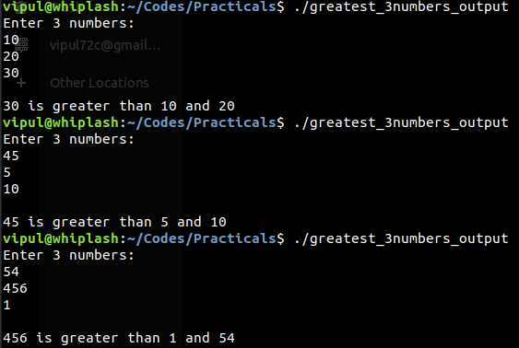

Program 6:

//Program to relate two integers using = , < , >.

#include<stdio.h>
int main(){
int num1,num2;
printf("Enter 2 numbers:\n");
scanf("%d %d",&num1,&num2);
if(num1>num2)
printf("\n%d>%d\n",num1,num2);
else if(num1<num2)
printf("\n%d<%d\n",num1,num2);
else
printf("\n%d=%d\n",num1,num2);



